LickCalc GUI documentation

Contents

Introduction 3

Note on nomenclature 3

Installation 3

Running from .exe file 3

Running from the command line 3

File Parameters 4

Loading a Med Associates file 4

Loading a .txt file or .csv file 4

Calculator Parameters 4

Interburst threshold 4

Interrun threshold 4

Graph Parameters 4

Ignore Long ILIs 4

Minimum burst 4

Plot burst probability 4

Output figures 5

(A) Session viewer 5

(B) Intraburst frequency 5

(C) Burst distribution 5

(D) Lick length 5

Output Parameters 5

File suffix 5

Default Folder 5

PDF 5

Excel 5

Text Summary 5

Note on acquisition of offset data and calculation of long licks. 5

Source code 6

References 6

# Introduction

This GUI will analyze lick timestamp data to provide parameters relating to lick microstructure. These parameters are believed to correlates with various psychological and physiological constructs including palatability, motivation, and post-ingestive influences. A fuller theoretical background is provided by the seminal papers and reviews in reference list.

## Note on nomenclature

Historically, in the field of lick microstructure the term *burst* has been operationalized differently across labs and researchers. In particular, a key distinction has been made by some between *bursts* (separated by ILIs>0.25 s) and *clusters* (separated by ILIs>0.5s), with the latter thought to be a more accurate reflection of the underlying psychological parameters of principal interest. For the purposes of this GUI, I have used the term *burst* throughout, as the GUI itself provides the opportunity to experiment with different methods of defining this unit (i.e. by changing the Interburst Threshold parameter). For a more in depth discussion, I recommend reading Davis & Smith (1992) and Spector, Klumpp & Kaplan (1998).

# Installation

The program has been written and tested in Windows 7/10 using Python 3.x. It should be possible to run it on Linux and Mac from the script but any feedback on making it more portable, universal and robust would be welcomed.

## Running from .exe file

Running from the .exe file is the simplest choice for Windows users. All that is needed is to download the .exe file to any folder and open it. The advantage is that it is simple, no installation is needed, and it is portable (e.g. should work fine from a USB drive). The disadvantage is that it is slow to initially open (depending on your machine may take from 20 seconds to 3 minutes, don’t give up on it early!) and you do not have access to the source code. If either of these bother you, then read the following instructions to run from the command line.

## Running from the command line

To run from the command line, you can try running the lickcalcGUI.py script and installing required packages as necessary or, if you are using Anaconda, you can use the included environment.yml file to create a specific environment with all packages installed.

1. Ensure Anaconda is installed (for Python 3.x)

<https://www.anaconda.com/distribution/>

2. Download the following files to a folder on your computer:

environment.yml and lickcalcGUI.py

3. Open an Anaconda terminal prompt and navigate to the folder that you downloaded the files to:

e.g. cd C:\Users\Your name\lickcalc

4. Create an environment:

conda env create -f environment.yml

5. Activate the environment:

conda activate lickcalc13

6. Start the GUI

python lickcalcGUI.py

# File Parameters

The GUI is able to load Med Associates data files (see below for details) or .txt and .csv files. Currently, it is not possible to use the Offset function with .txt and .csv files.

## Loading a Med Associates file

Med Associates files need to be stored using “Stripped with Variable Identification - FORMAT 4”. For more information see page 49 of <https://www.med-associates.com/wp-content/uploads/2017/01/DOC-010-R1.6-SOF-735-MED-PC-SOFTWARE-MANUAL.pdf>.

To load a file in this format, click Load Med File and select the desired file.

## Loading a .txt file or .csv file

Click Load CSV/txt File and select desired file.

# Calculator Parameters

Once a file is loaded, lick arrays that the program has identified will be show in the Onset and Offset dropdown menus.

## Interburst threshold

This is the minimum interlick interval used to separate bursts (or clusters of licking). Although the ideal value has been debated, most believe that a value of 0.5-1 second is most appropriate. See Spector

## Interrun threshold

This parameter is currently non-functional.

# Graph Parameters

## Ignore Long ILIs

When this is selected, the ILIs sheet in the Excel file that is saved will only include ILIs < interburst threshold. These data can be used to examine the intraburst lick frequency.

## Minimum burst

This parameter provides a minimum burst size. In many experiments, researchers only consider a burst to have occurred when at least 3 licks have occurred with an ILI < burst threshold. This removes accidental contacts with the sipper.

## Plot burst probability

When this is selected, instead of a histogram showing licks/burst, a cumulative probability plot is shown. These data can be used to examine the probabilistic distribution of bursts. Data will be fitted with a Weibull distribution and estimated parameters for alpha, beta and the r-squared of the fit are provided. For more information on these parameters see Davis (1996). These parameter estimates are included in the summary outputs.

# Output figures

## (A) Session viewer

This figure shows the occurrence of licks across the entire behavioral session.

## (B) Intraburst frequency

This figure shows a histogram of interlick intervals that are below the threshold separating bursts.

## (C) Burst distribution

This figure shows a histogram of licks/burst. If Plot Burst Prob is selected the figure instead shows the probabilistic distribution of these data.

## (D) Lick length

This figure shows a histogram of lick lengths and gives data on licks that fall outside the normal distribution. These data are only available if lick offset times have been provided. See note below on the advantages of measuring lick offset times and determining lick lengths.

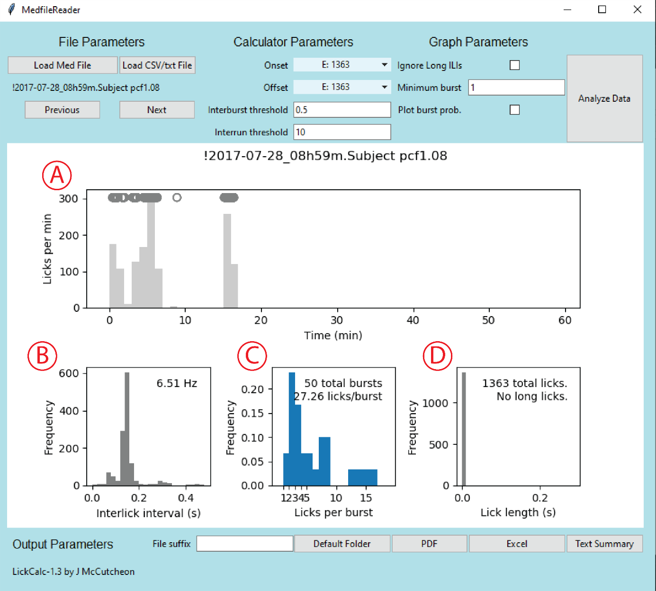

# Output Parameters

## File suffix

By default, the input filename will be used as the output filename. Therefore, this field can be used to add a suffix to the saved file name, for example, if multiple analyses are performed for the same file.

## Default Folder

This can be used to select a default folder to save output files in.

## PDF

This will make a PDF of the current output figures.

### Excel

This will write an Excel file with summary data and arrays of lick timestamps, ILIs, and burst data.

## Text Summary

This will write a simple text file with summary data.

# Note on acquisition of offset data and calculation of long licks.

When contact lickometers are used to detect licking, unless the spout is properly positioned it is possible for a fluid bridge to form between the animal’s tongue and the spout such that individual licks fail to be registered. This can be prevented by using a different method of measuring licks (e.g. a force lickometer). However, for most this is not feasible so proper bottle position is essential, generally, this means that the spout should be recessed out of the chamber so the animal needs to reach through the chamber wall to gain access.

To guarantee the fidelity of our data, we have also set our lickometers up so that we record the times of both the lick onset and lick offset. In this way, we can check whether a significant number of “long licks” have occurred.

With Med Associates systems, this requires the lickometer input to be set to Level mode (rather than Toggle mode) and I have a short piece of example code on the Github site that when used will output onset and offset arrays for lickometers.

For other lickometer systems, it may be necessary to use another method of measuring offset times.

# Source code

All source code for the GUI are available at <https://github.com/mccutcheonlab/Lick-Calc-GUI>. Comments and feedback will be welcomed at j.mccutcheon *at* uit.no

# References

Davis JD & Smith GP (1992). Analysis of the microstructure of the rhythmic tongue movements of rats ingesting maltose and sucrose solutions. *Behav Neurosci* **106:** 217-228.

Davis JD (1996). Deterministic and probabilistic control of the behavior of rats ingesting liquid diets. *Am J Physiol* **270:** R793-800.

Johnson AW (2018). Characterizing ingestive behavior through licking microstructure: Underlying neurobiology and its use in the study of obesity in animal models. *Int J Dev Neurosci* **64:** 38-47.

Naneix F, Peters KZ & McCutcheon JE (2019). Investigating the effect of physiological need states on palatability and motivation using microstructural analysis of licking. *Under review*

Spector AC, Klumpp PA & Kaplan JM (1998). Analytical issues in the evaluation of food deprivation and sucrose concentration effects on the microstructure of licking behavior in the rat. *Behav Neurosci* **112:** 678-694.